GIT Tutorial

GIT can be a bit intimidating to use at first so here is a helpful tutorial on how to use GIT.

Chapter 1: Setting up a repo

To begin with GIT you will first need a repository to work in. The repository will be shared with you by the project manager to your github account. Once it has been shared with you clone the repository to your computer.

This is your home Screen for GIT:

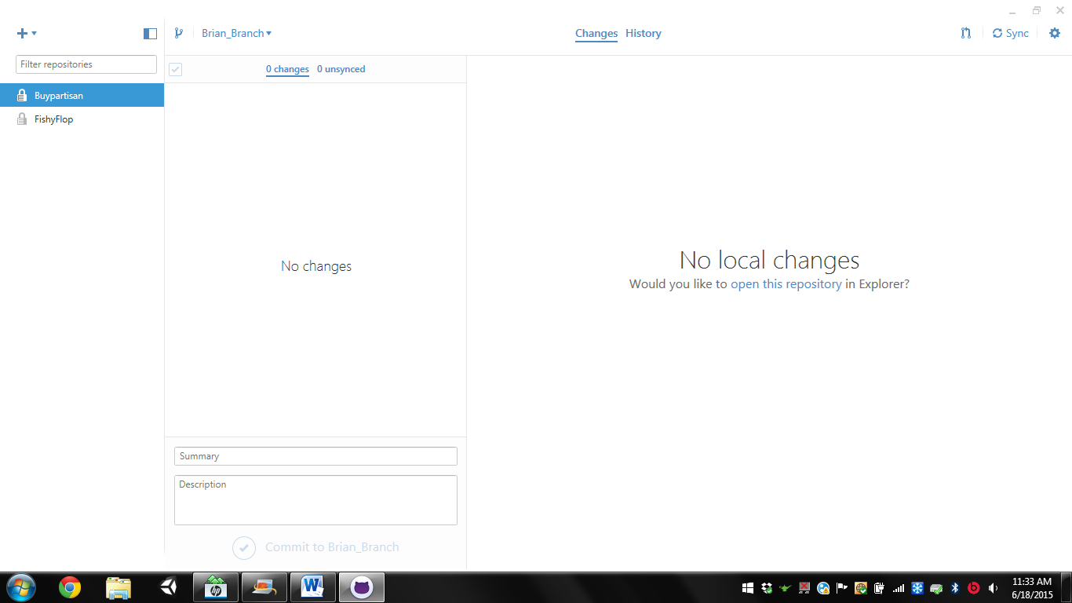

First Click the plus icon in the top left:

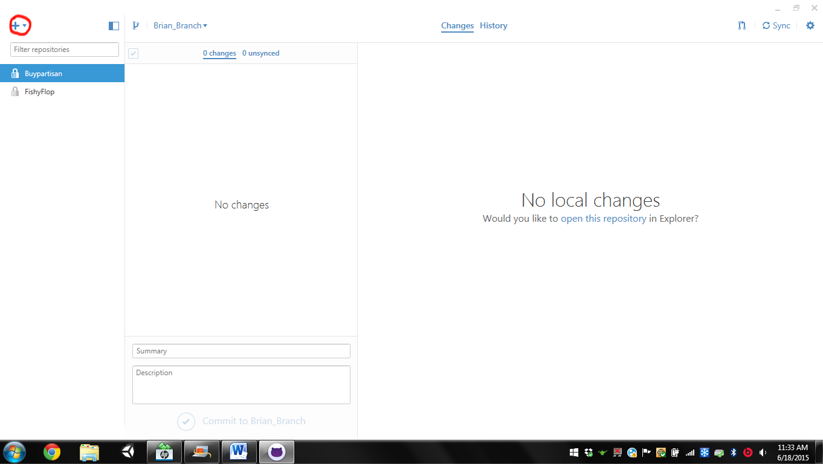

Next Click Clone(1), The project you wish to Clone(2), Finally Clone it with the button at the bottom (3).

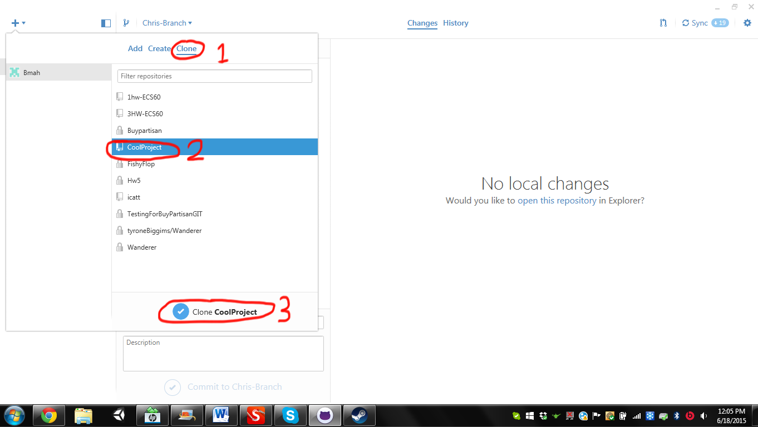

Once you have cloned the project and selected a place in your computer to place it you should create a branch and begin work!

Chapter 2: Creating and pushing to branches along with the design document and asana tasks.

To create a branch click this button in the top left(1), enter in your branch name(2), and create the new branch(3).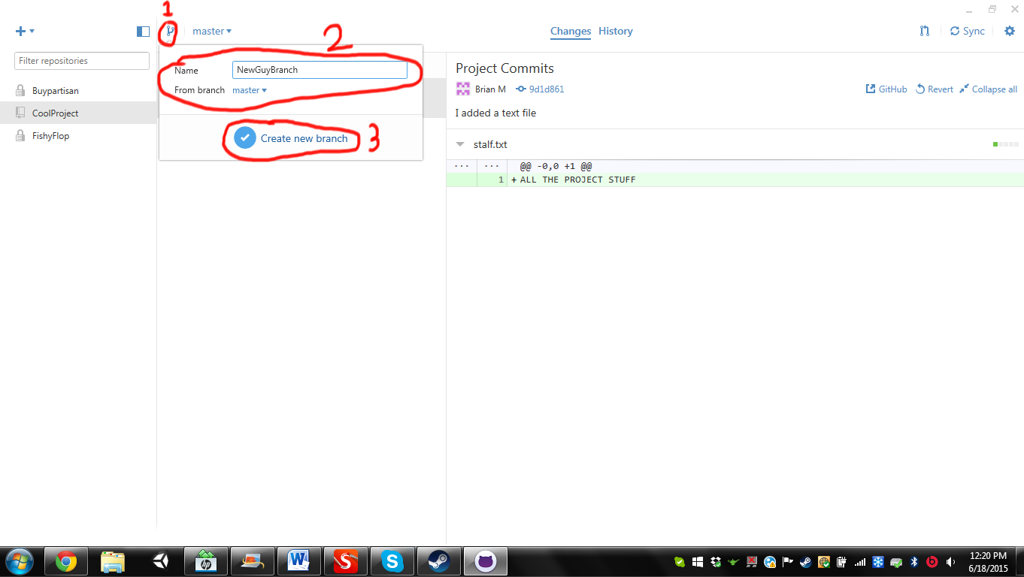

Be sure you are on your own branch you are ready to start work!

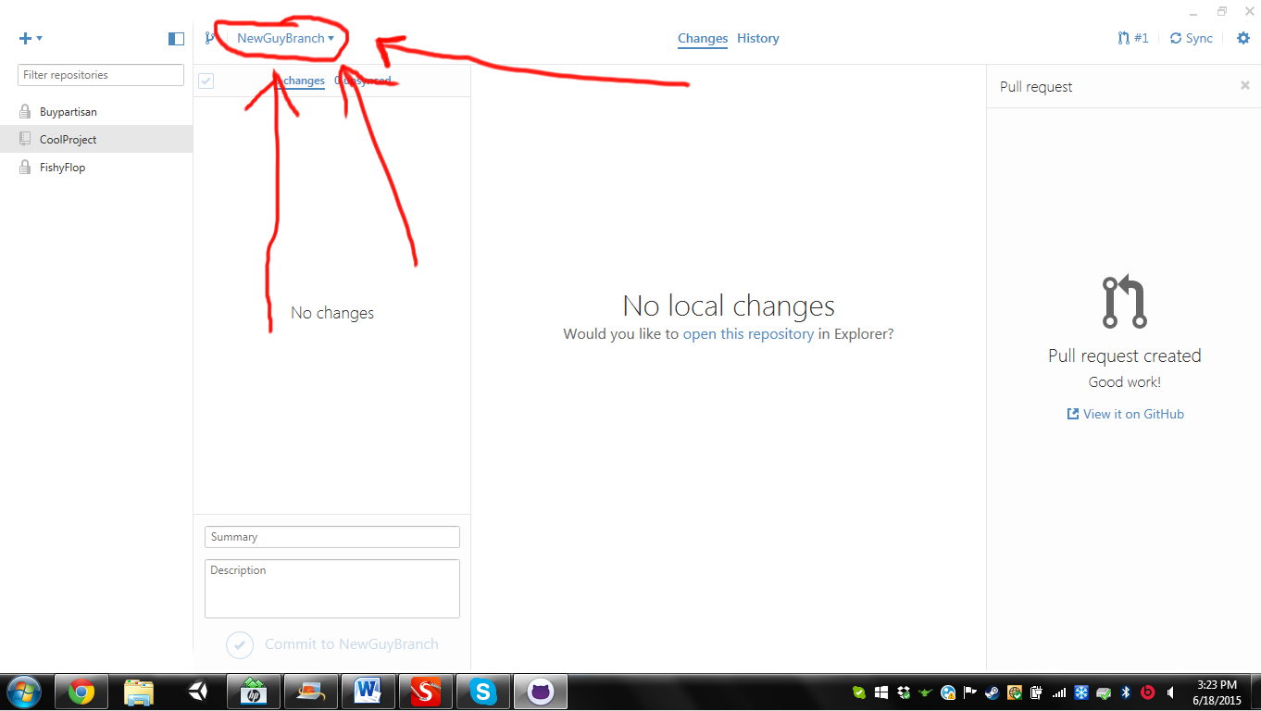

To start go onto asana and find a task from the tasklist. Click the person icon(1), assign the task to yourself(2), Follow the directions on the right(3).

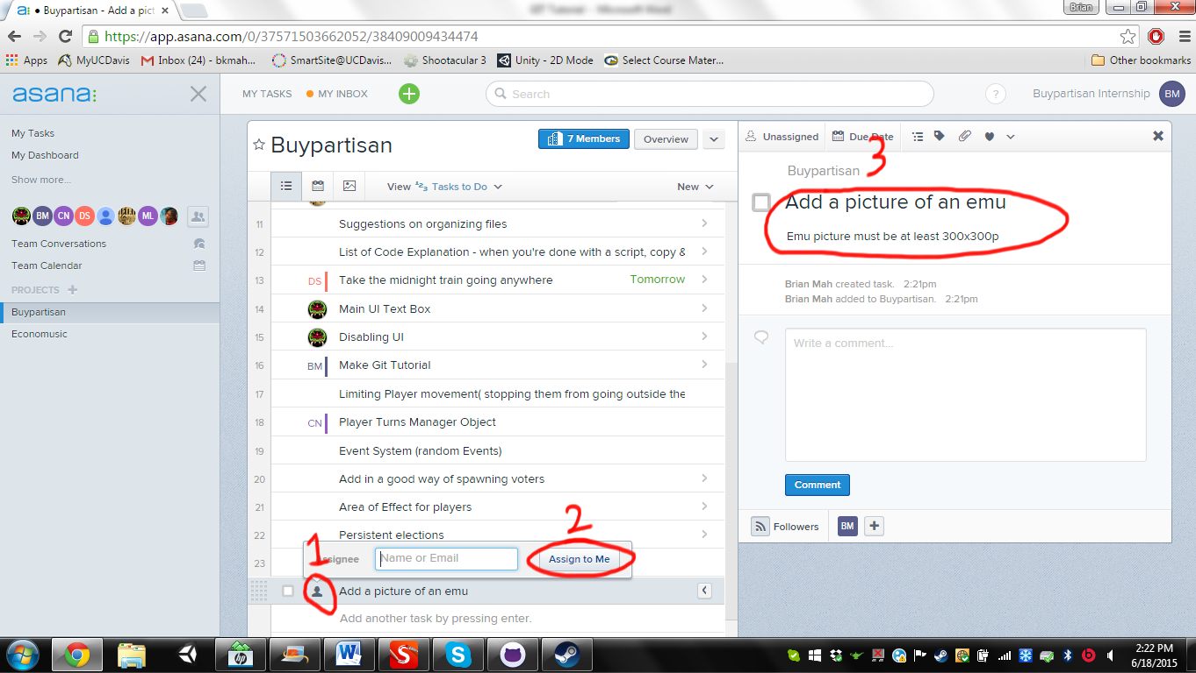

Next go to the checkout google spreadsheet and checkout any files which you may need. Find the file you need(1). Put your name next to it(2). If someone’s name is already there get in contact with them and see when it will be available.

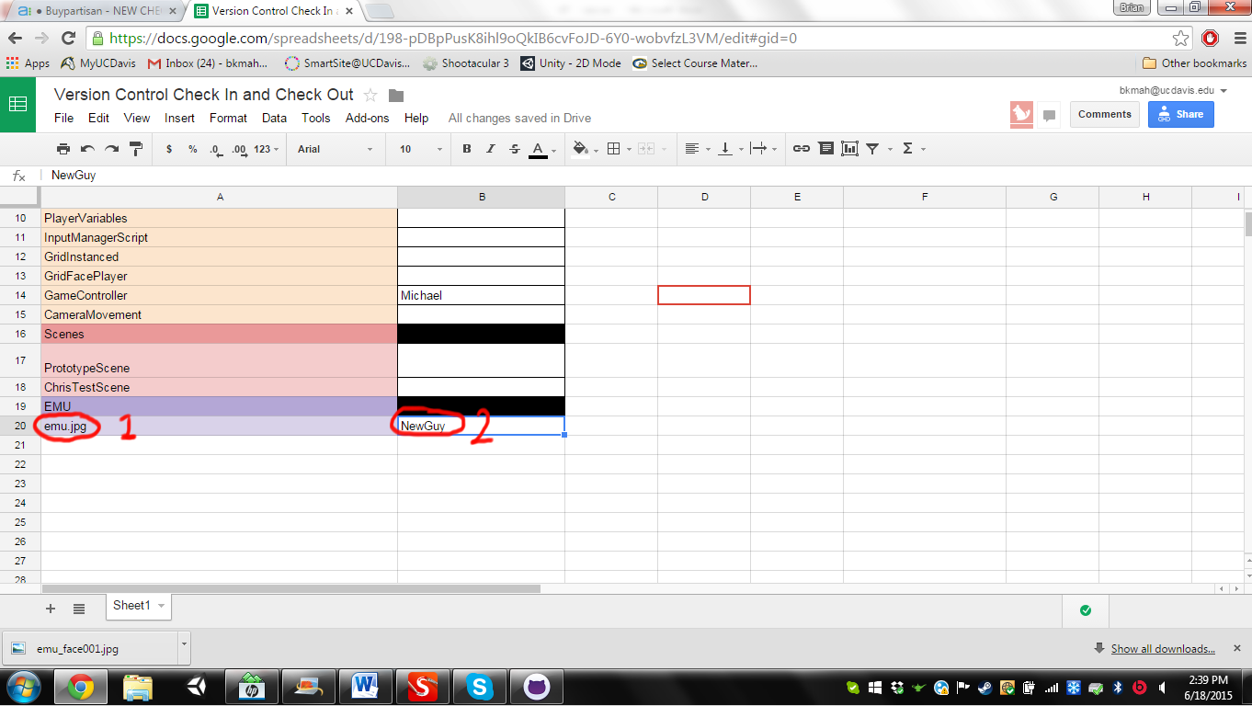

Once the task is done go to GIT. Changes will be listed in the changes bar(1). The specifics of each change will be listed in the expanded view on the right(2). Be sure to check these changes to make sure you do not alter something which you did not checkout. Give your commit a descriptive name(3) and description(4). When everything is in order hit the commit button to commit the changes onto your local computer.

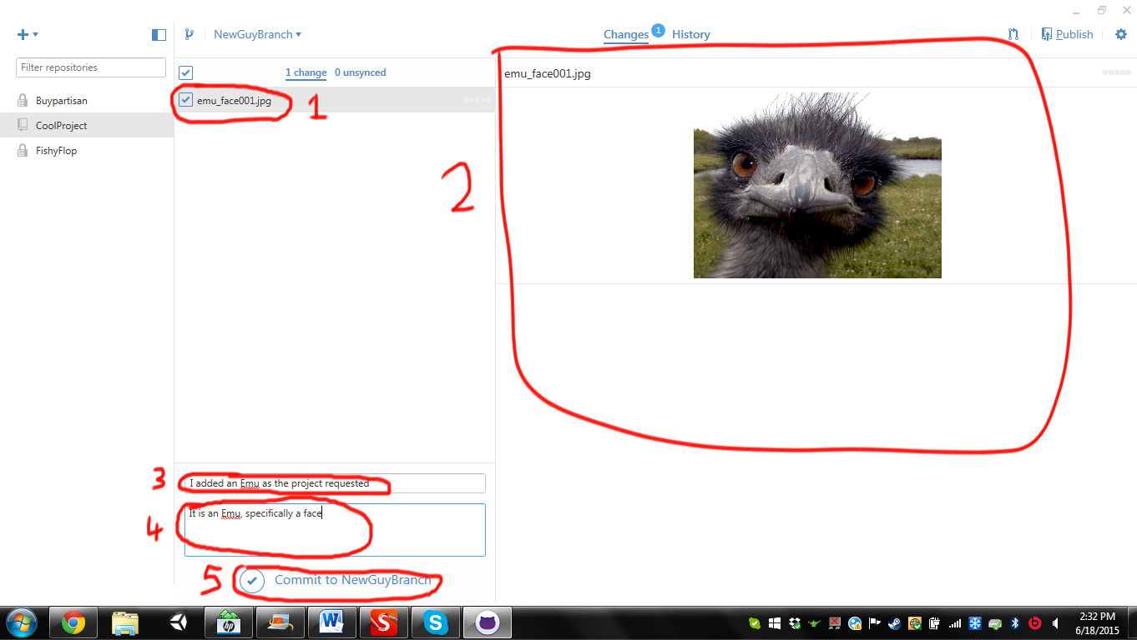

Once done it should look like this:

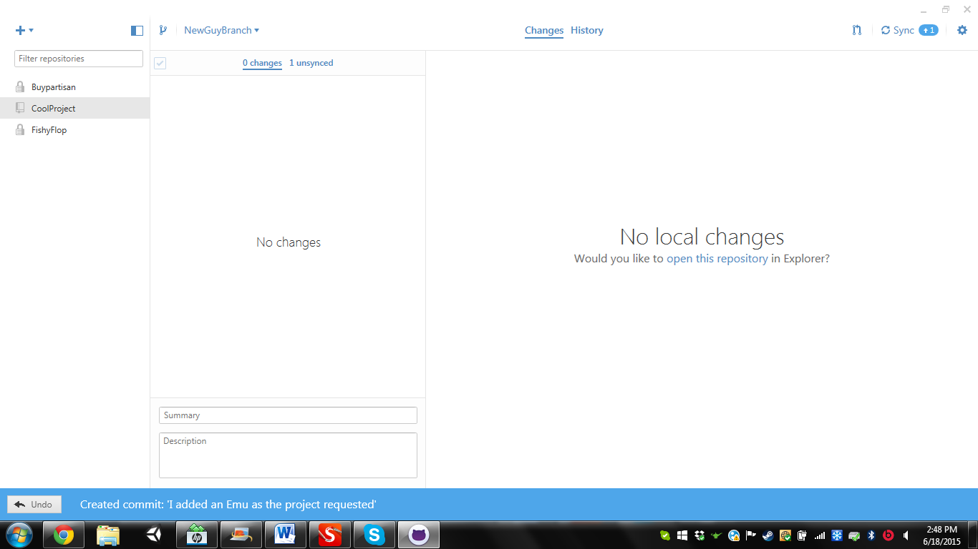

Sync the changes in the top right:

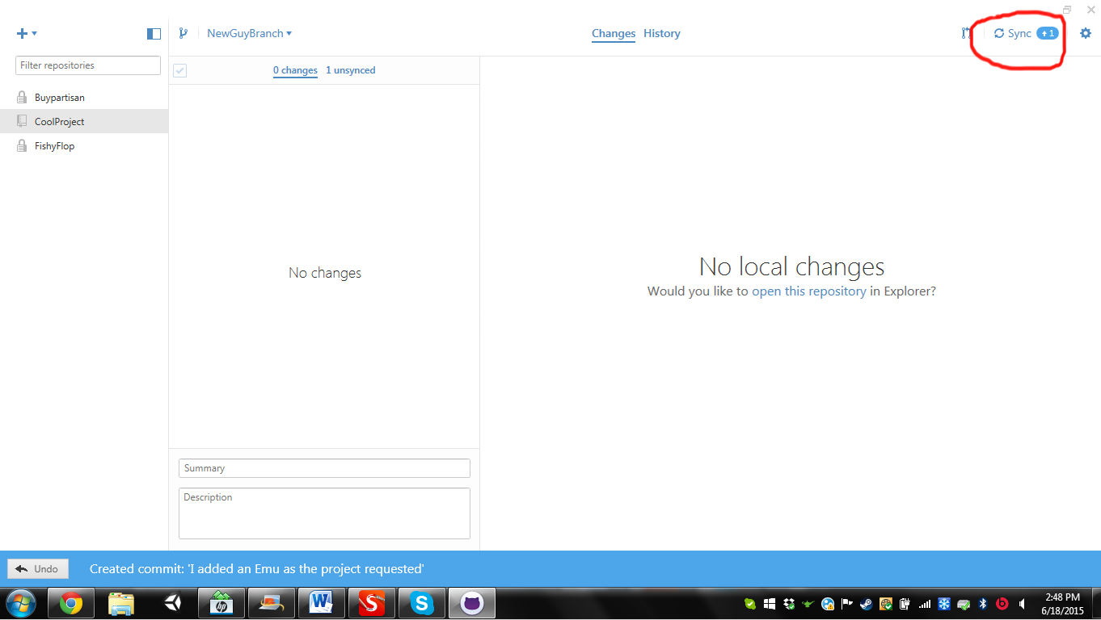

Once all of these are done you are ready to merge branches! Hit the button in the top right(1). Make sure the branch goes from your branch into master(2). Give the pull a descriptive name that tells people what you are putting into main(3). When everything is in order hit the Send Pull request button(4).

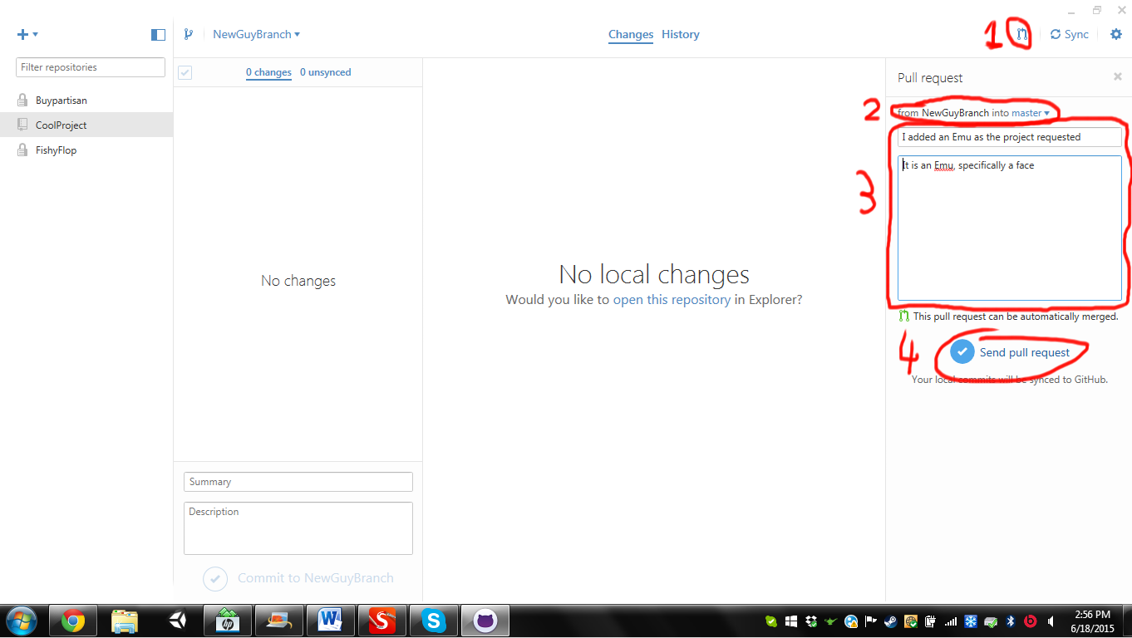

Once you pull view it on github with this button

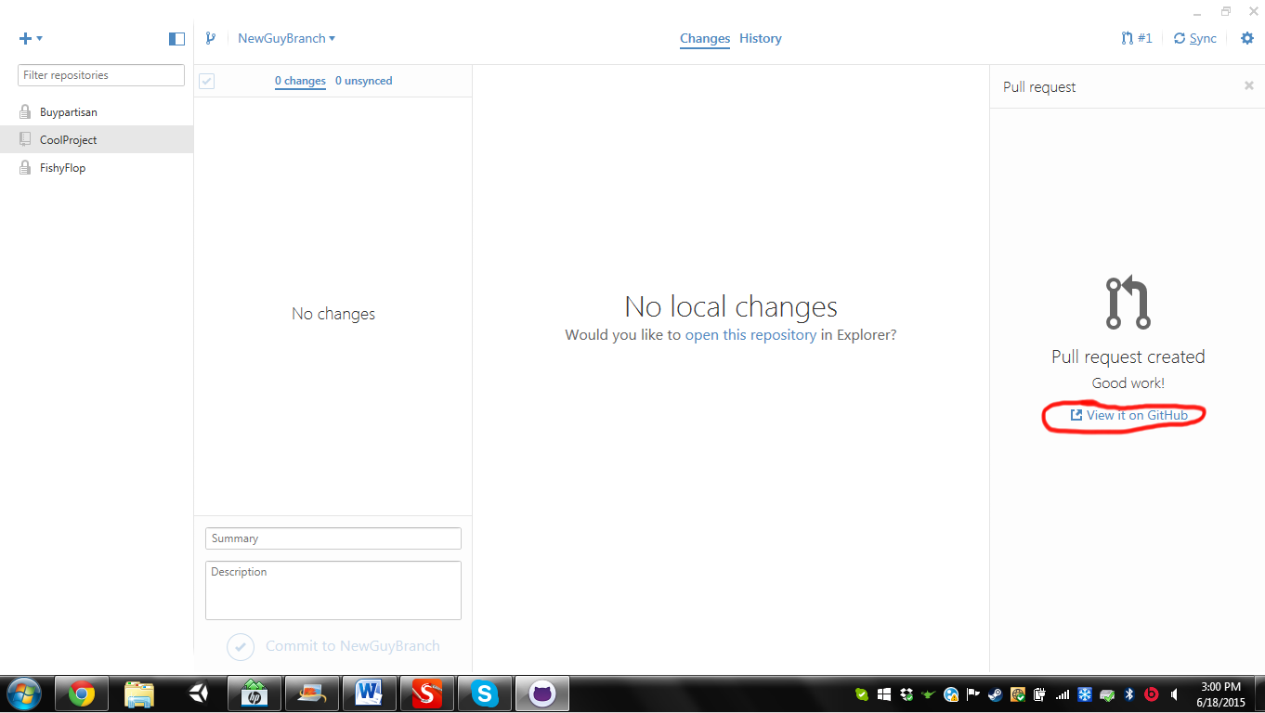

On Github hit the merge pull request button!

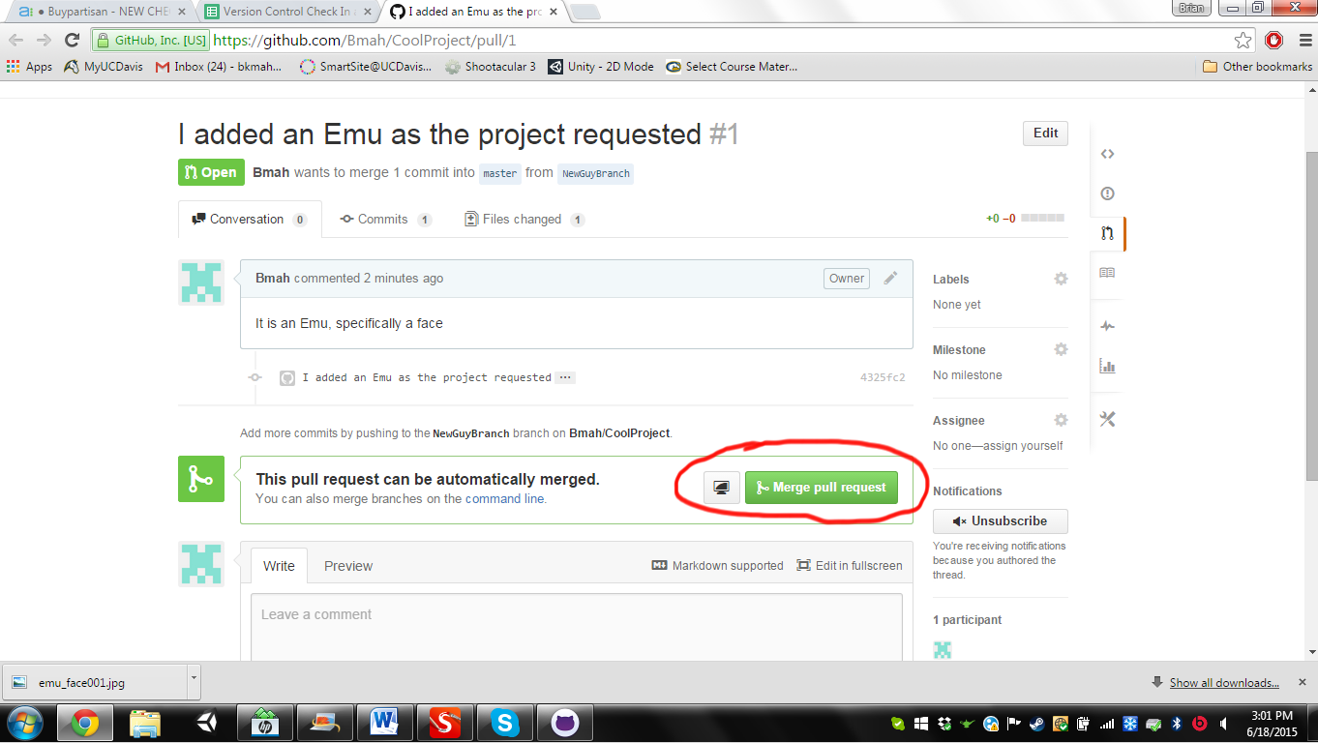

Congrats you have now successfully added a feature to the master branch!

Now we have to mark the task on asana. Add any relevant comments that describe how you implemented the task(1). Then mark the task as complete(2).

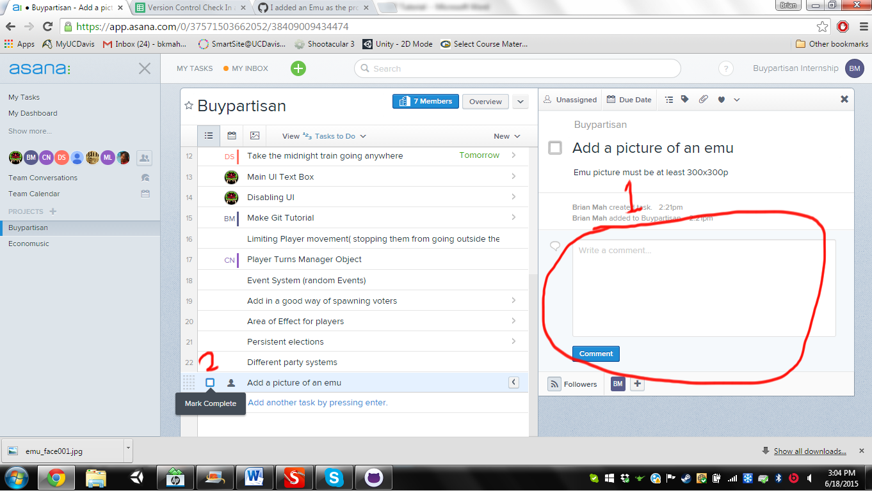

Also be sure to delete your name from the checkout.

